**Jenkins Assignment :1**

**Name :Rutwija Unde**

**Sub: Branching with jenkins**

**Github Repository:**

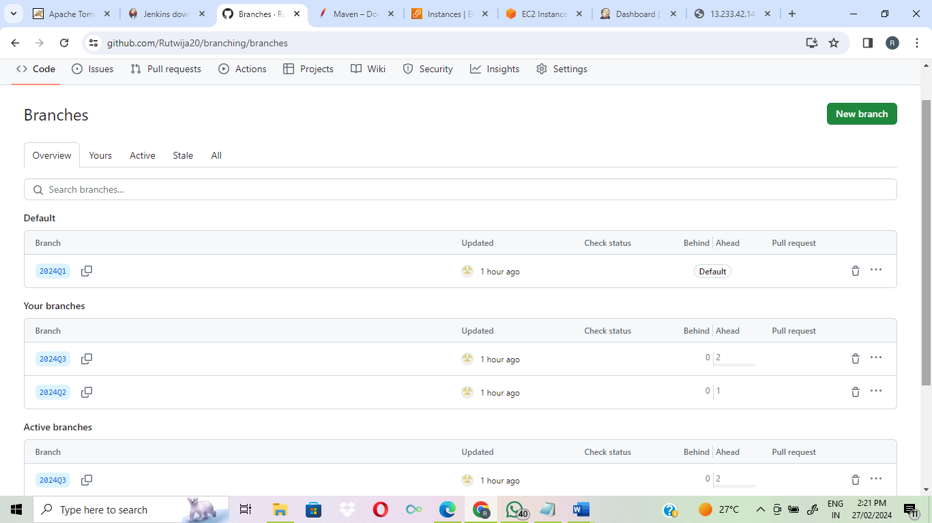

**Create 3 jobs for 3 branches 2024Q1,2024Q2,2024Q3**

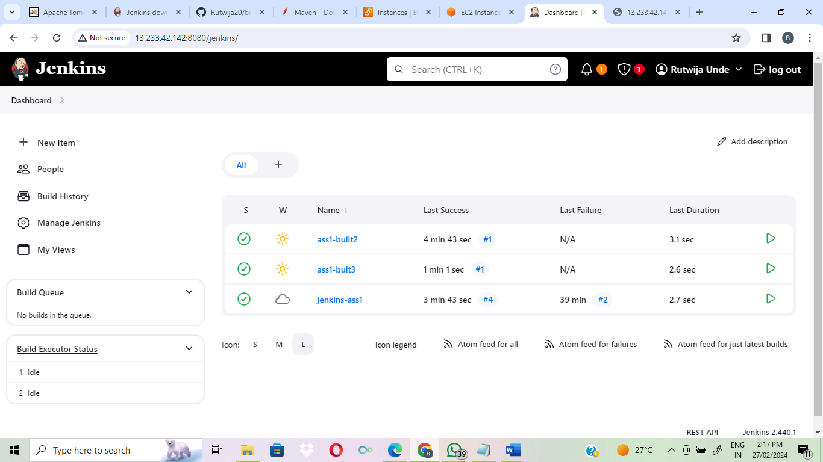

**Deploy on httpd and access 2024Q1 branch:**

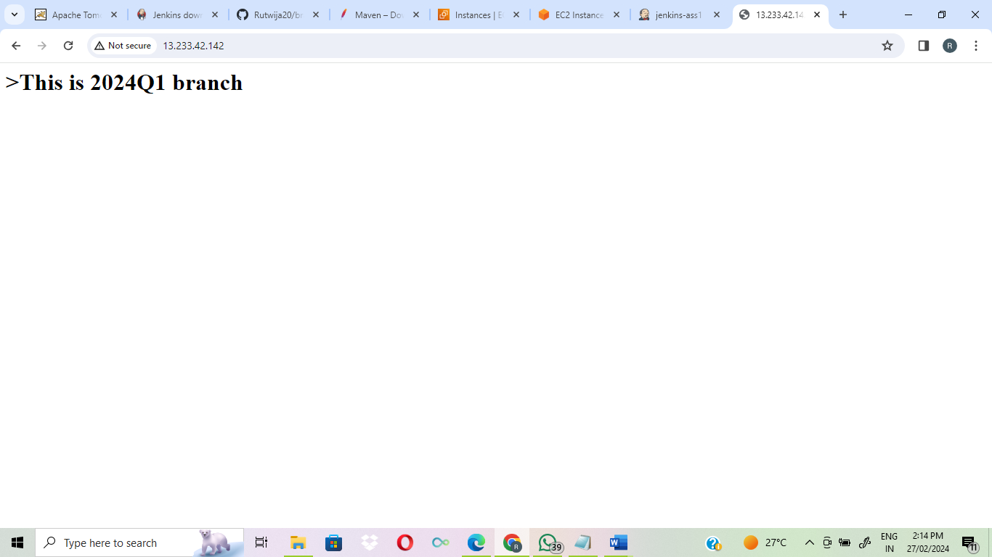

**Deploy on httpd and access 2024Q2 branch:**

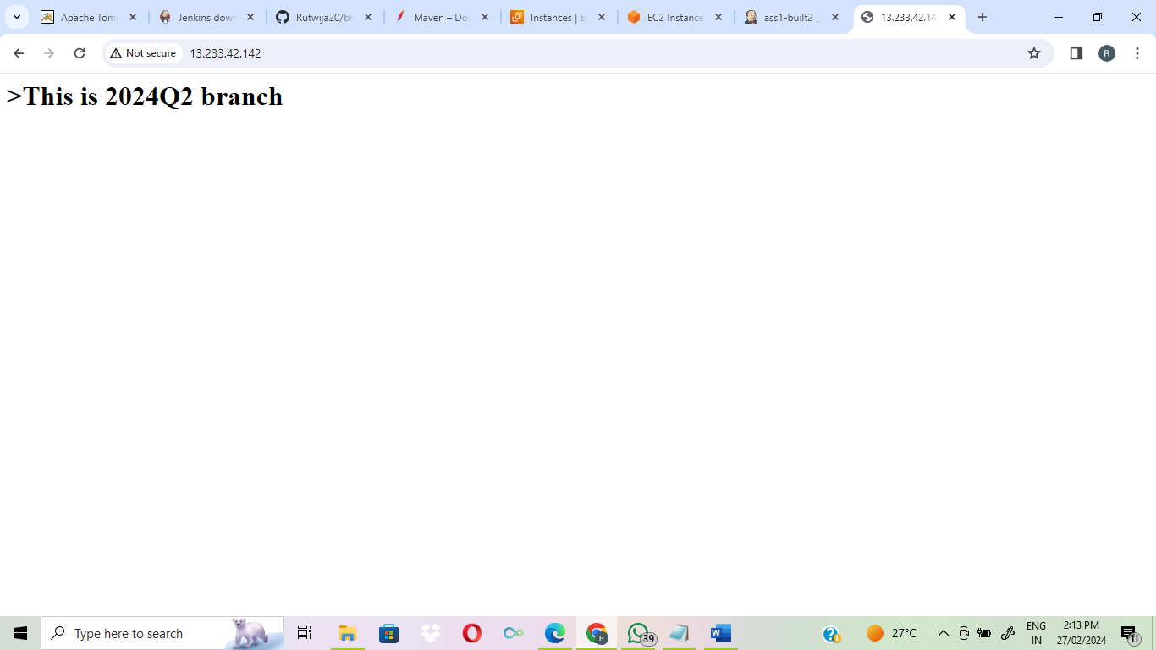

**Deploy on httpd and access 2024Q3 branch:**

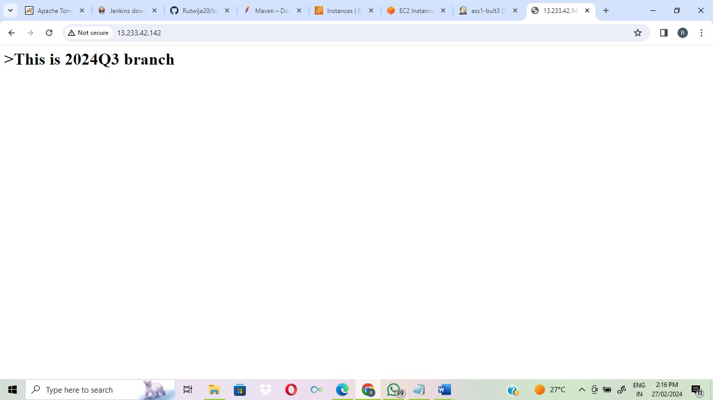

**Configuration for deployment:**

